

Where to find Resources
The website is being updated and the JPP resources can be found on the old site:

https://www.jesuitinstitute.org/old-resources

The new website is:

https://www.jesuitinstitute.org
The Examen:

https://www.jesuit.org.uk/spirituality/examen

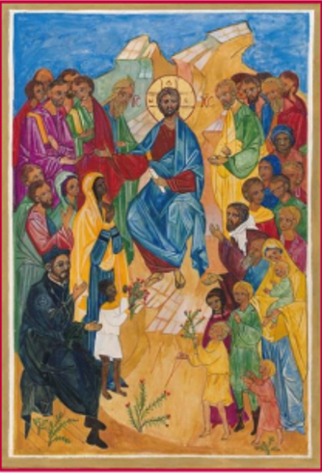
A Teacher’s Prayer
Lord, you have called me to teach
and you give me your son, Jesus the Teacher, as my guide.
You send me to be your face and word in school today,
to bring your message of faith, hope and love.
With my pupils may I be always patient and understanding
and never resentful or despairing.
With my colleagues may I be always generous and supportive
and never dismissive or hurtful.
With those entrusted to lead the school may I be always considerate and constructive
and never obstructive or difficult.
With myself may I be always grateful for daily blessings and never take things for granted.
With everyone I encounter today
may I be just in my actions and forgiving with my words.
May I praise, not criticise; encourage, not deter;
help, not hinder; accompany, not direct;
and bring light and joy to those I meet.
May my lessons be truthful and inspiring
as they reveal the wonderful traces of your presence in creation
and in the best of humankind.
May my classroom be a place of peace and respect, discovery and learning,
where each person is given space and encouragement to flourish,
growing to be the person you call them to be.
Give me energy, and faith and commitment,
especially when I am tired or despondent,
let down, or wondering if my efforts are worthwhile.
Give me the wisdom and strength of your Spirit, today and each day,
that I may help the souls committed to my care for the common good
and for your greater glory. Amen.

Christ the Teacher Icon Notes.pdf

