**STATUTORY CONSULTATION**

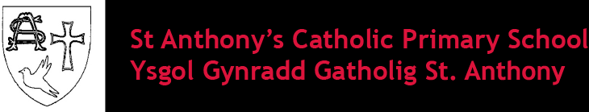

Proposal to Reorganise the Catholic Education Provision in Flintshire

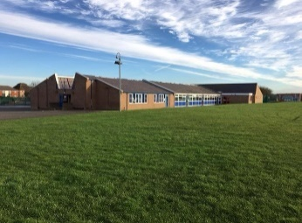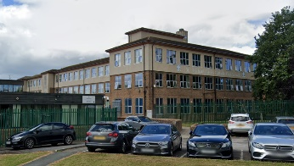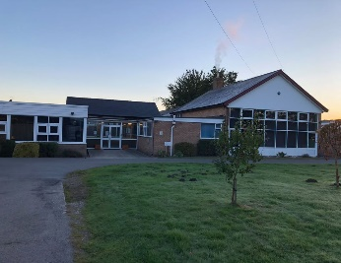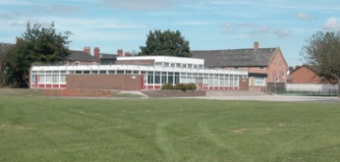

**The closures of St Anthony’s Catholic VA Primary School in Saltney, St David’s Catholic VA Primary School in Mold, St Mary’s Catholic VA Primary School in Flint and St Richard Gwyn Catholic VA High School in Flint.**

**The opening of a new English medium 3-18 Catholic Voluntary Aided School in Flint.**



**Consultation Period: ?? May 2025 to ?? June 2025**

# FOREWORD

“The mission of the school is to develop a sense of truth, of what is good and beautiful. And this occurs through a rich path made up of many ingredients”.



Right Reverend Peter Brignall

Bishop of Wrexham

“True education enables us to love life and opens us to the fullness of life”.

These words of Pope Francis addressed to school teachers in Italy on 10 May 2014, together with many educational documents and policies of the Catholic Bishops of England and Wales, have been an inspiration to me as I explore new patterns of collaboration between the schools of the Diocese of Wrexham. My core purpose is to ensure the future viability of our schools and to provide the best possible education for the children entrusted to our care.

Within the Diocese of Wrexham, part of our mission is to build on our current good practice to ensure the future excellence and viability of Catholic education. This mission is based on strong spiritual values and sound educational research. Our ambition is:

* The creation of a world class Catholic education system that enables all the children of the Diocese to achieve their spiritual, educational and human potential.
* To work closely with stakeholders on re-structuring our schools to deliver a sustainable system that is fit for the future.
* To provide a Catholic education for all those who wish to be educated within a Catholic setting and ethos

We aim to review our school provision with this in mind.

Our mission is wholly in line with Welsh Government’s aspirations for education. This is backed by Organisation for Economic Co-operation and Development (OECD) evidence. I am conscious of the need for closer working between our schools. Our proposal for a new 3-18 school to replace St Anthony’s, Saltney, St David’s, Mold, St Mary’s, Flint and St Richard Gwyn, Flint which will allow for a seamless transition from early years up to A Level. It will put us in an advantageous position to deliver the new curriculum and give our children the benefits of an uninterrupted educational journey. It will allow us to continue to build upon the very good education currently offered by those schools in a state-of-the-art campus.

I firmly support this proposal which will develop:

* a learning campus where children will develop their faith, skills and knowledge as confident citizens of the 21st century who are proud of their community, language and heritage;
* continued improvement founded on current good practice;
* a campus with excellent facilities for each age range;
* a centre of excellence in Catholic teaching and learning that works in close partnerships with all its feeder church schools;
* a worship and social centre for the schools’ parishes and the community;
* A net zero carbon all through school;
* Shared leadership and excellence in governance

This consultation process will give all associated with our community of Catholic schools in Flintshire the chance to ask questions about this exciting proposal. It is important that the vision of what can be achieved for our community is shared and understood by all.

I am confident that the proposed 3-18 Catholic school will be a strong and nurturing environment. I know the school will build on the ethos, successes and achievements already recognised in the four separate schools it will replace.

Your children deserve nothing less.

<Insert Signature>

The Right Reverend Peter Brignall

Bishop of Wrexham



Neal Cockerton

Chief Executive, Flintshire County Council

<Insert Foreword from Neal Cockerton>

CONTENTS

A. FOREWORD 2

B. OVERVIEW 7

B.1. Introduction 7

B.2. Overview of the Proposal 8

B.3. Consultation Requirements 8

B.4. Who will be consulted? 9

B.5. How to respond to the consultation 9

B.6. Contact details 10

B.7. What will happen next? 11

C. THE CASE FOR CHANGE 12

C.1. Background to the Proposal 12

C.2. Current Position 13

C.3. School Locations 18

C.4. Demographical Information 18

C.5. Pupil Forecasts 24

C.6. Quality of Education Provision 29

D. THE PROPOSAL 33

D.1. What is being proposed? 33

D.2. What will the proposal provide 33

D.3. When will the proposal be effective? 33

D.4. Cost of the Proposal 34

D.5. Options Considered 35

D.6. What will the preferred proposal achieve? 38

E. LIKELY IMPACTS OF THE PROPOSAL 38

E.1. Impact on the Local Environment 38

E.2. Impact on Admissions 39

E.3. Impact on Home to School Transport 39

E.4. Impact on Transfer to Secondary Schools 40

E.5. Impact on Additional Learning Needs Pupils 40

E.6. Impact on Governance Arrangements 41

E.7. Impact on Staffing 41

E.8. Impact on Other schools 41

E.9. Risks of the Proposal 45

E.10. Integrated Impact Assessment 46

E.11. Impact on Welsh language provision 46

E.12. Building Impacts 47

E.13. Interim Arrangements 47

F. RESPONSES 48

F.1. Consultation Response Pro-forma 48

**This consultation document is published in hard copy, if you require a paper copy of this document, or a copy of the document in a different format for example braille or large print, or help with interpretation in a different language, please contact the School Modernisation Team on 01352 704014 / 01352 704015, or e-mail 21stCenturySchools@flintshire.gov.uk.**

# OVERVIEW

## Introduction

This consultation document is an opportunity for consultees and other interested parties to learn about changes and give feedback on the proposal to reorganise the Catholic education provision in Flintshire.

This document represents Flintshire County Council’s (the Council) responsibilities as part of the School Standards and Organisation (Wales) Act 2013, to consult with appropriate stakeholders when giving consideration to any significant school reorganisation.

Following the regulatory guidance of the School Organisation Code 2018, the Council wish to consult interested stakeholders regarding reorganisation of the Catholic education provision in Flintshire. The proposal involves the closures of St Anthony’s Catholic VA Primary School in Saltney, St David’s Catholic VA Primary School in Mold, St Mary’s Catholic VA Primary School in Flint and St Richard Gwyn Catholic VA High School in Flint. The proposal also involves the opening of a new English-medium 3-18 Catholic Voluntary Aided School in Flint.

The consultation provides stakeholders with an opportunity to ask questions, make comments, and share their views on the proposals being put forward. Responses to this consultation will be reviewed carefully when the Council considers whether the proposal should be taken forward to implementation.

This document sets out information which consultees should consider to fully participate in the consultation process.

***Any figures, statistics and material referenced in this document are the most accurate available at the time of preparation and publication****.*

## Overview of the Proposal

The Council is seeking your views on a proposal to reorganise the Catholic education provision in Flintshire.

The council proposes to deliver this reorganisation by:

* Closing St Anthony’s Catholic VA Primary School in Saltney, St David’s Catholic VA Primary School in Mold, St Mary’s Catholic VA Primary School in Flint and St Richard Gwyn Catholic VA High School in Flint.
* Opening of a new English medium 3-18 Catholic Voluntary Aided School in Flint

To achieve these changes, the Council, in partnership with Welsh Government, is planning to invest £55m in a new school

*Note: this proposal is running concurrently with the proposal to amalgamate Saltney Ferry CP School and Wood Memorial CP School, Saltney.*

## Consultation Requirements

The Council has a responsibility as part of the School Standards and Organisation (Wales) Act 2013 to consult with appropriate stakeholders when giving consideration to any significant school reorganisation proposals.

The School Standards and Organisation (Wales) Act 2013 and School Organisation Code 2018 describes a number of regulated alterations to maintained schools, which must not be carried out unless the relevant local authority and/or governing body have complied with the requirements imposed by the Code.

Statutory procedures are usually necessary to make significant changes to schools. The procedures are designed to enable changes to be made where they are considered necessary, but in a way which protects the interests of learners and allows interested parties the opportunity to have their say in the process. Welsh Government have published these procedures within the School Organisation Code 2018 (“the Code”).

The formal consultation process will operate for at least 42 days, with at least 20 of these being school days. There will be opportunities to ask questions and make comments that will be considered when the Council determines whether or not the proposal is to be implemented.

In accordance with the agreed children and young people’s participation standards for Wales, Article 12 of UNCRC established that “Children have the right to say what they think should happen, when adults are making decisions that affect them, and to have their opinions taking into account”.

The views of children and young people are extremely important to the Council, therefore children and young people will be provided with opportunities to contribute to this consultation process. The Council has produced a summary version of this document which will be made accessible for all children and young people affected by this proposal.

## Who will be consulted?

This consultation will take place between **?? May 2025 to ?? June 2025**. This allows ?? days for responses to be received, ?? of which are school days.

This formal consultation document has been sent to a wide range of consultees including:

<insert stakeholder list>

This document has been published on the Flintshire County Council website and can be found by following the link below:

<http://www.flintshire.gov.uk/en/Resident/Schools/School-Modernisation-Related/Home.aspx>

## How to respond to the consultation

Your views on the proposals to reorganise the Catholic education provision in Flintshire are important to us. The Council wants you to engage in this consultation and tell us what you think of the proposal, particularly if they may affect you or your children.

The Council is now engaging in statutory consultation processes with all interested parties to ensure that any decision taken by the Council is one that is informed.

The timescales for the formal consultation aspects of these statutory proposals are:

|  |  |  |
| --- | --- | --- |
| **Statutory Consultation Period Commences** | **Statutory Consultation Period Ends** | **Period Of Consultation** |
| ?? May 2025 | ?? June 2025 | ?? days, ?? of which are school days |

You can respond to this consultation by completing the online questionnaire which is available on our website or by following this link:

<insert link>

<insert QR code>

A paper copy of the questionnaire is also available at the back of this document. Alternatively, you can respond in writing using the contact details on the next page.

Large print, Braille, and alternative language versions of this document will also be made available upon request via the contact details below. We welcome correspondence in Welsh and English and you will receive a response in the same language. Use of either language will not lead to a delay.

To allow children and young people to participate in this consultation, a version of this document has been created that is relevant to their age and their level of likely understanding. This presents the information in a friendly way and allows children and young people to reach an informed decision. The document can be found here:

<insert link>

All responses must be received by midnight **?? June 2025.**

The Council is not proposing any public drop-in events during this consultation. Instead, questions can be submitted by e-mail to 21stCenturySchools@flintshire.gov.uk. Council Officers will provide a response within 7 days.

Staff and Governor events have been co-ordinated with the individual schools.

<need to arrange>

## Contact details

All responses should be sent to the following address:

* School Modernisation Team

Flintshire County Council

Ty Dewi Sant

St David’s Park

Ewloe

Flintshire CH5 3XT

* E-mail: 21stCenturySchools@flintshire.gov.uk
* Phone: 01352 704014 or 01352 704015

A post-box will also be available at St Anthony’s, St David’s, St Mary’s and St Richard Gwyn receptions to post responses.

<TBC>

## What will happen next?

Once the consultation period has ended, a Consultation Report will be produced which will outline the feedback received. The Council’s Cabinet will consider the consultation report and will decide whether or not they wish to proceed with the preferred option outlined in the consultation document. **It should be noted that responses received during this period will not be logged as objections to the proposal**.

If the first part of the process is approved to proceed by the Council’s Cabinet, a **Statutory Notice** will be published, followed by a period of 28 days for you to submit formal objections in writing. To be considered as a statutory objection, an objection **must** be made in writing or by email at the addresses above within the 28-day timescale.

Following the Statutory Notice period the Council’s Cabinet would then need to consider another report, summarising any objections and issues raised and the Council’s response to them, called the **Objection Report**. This will determine whether or not to proceed to implementation. This report will also be available for all persons to view on the Council’s website or by request for a hard copy.

The Council’s Cabinet will determine whether to approve, or not, the proposal after consideration of the Objection Report.

Once a decision has been made an electronic copy will be sent out to all interested parties called a **Decision Notification** within 7 days of the decision.

The proposed timetable for decision making following the formal consultation process is:

|  |  |
| --- | --- |
| **Stage of Process** | **Key Dates** |
| Cabinet consider the results of the consultation and determines whether to proceed with proposals | September 2025 |
| Council publish statutory notice and enter into an objection period | September 2025 |
| Cabinet consider the objection report and determine whether or not to implement the proposals | January 2026 |
| Decision notification letter is issued with outcome from Cabinet determination | January 2026 |

The remainder of the consultation document sets out the rationale for the proposed changes to reorganise the Catholic education provision in Flintshire. We would like you to consider the information contained within this document and to hear your views as to whether or not you support the proposals.

# THE CASE FOR CHANGE

## Background to the Proposal

This school modernisation proposal is necessary because the local authority must ensure the following:

* Provision of high-quality and sustainable education.
* Improvement of school buildings and facilities.
* Availability of the right number and type of school places in the right locations.
* Addressing unsustainable school buildings and supporting infrastructure.
* Recognition that inaction will lead to higher pupil-teacher ratios as funding decreases.
* Maximisation of external funding through the Welsh Government's Sustainable Communities for Learning Programme.

To enable this proposal to the Catholic education provision in Flintshire, the Council seeks your views on the proposal.

The Council proposes to deliver this reorganisation by:

* Closing St Anthony’s Catholic VA Primary School in Saltney, St David’s Catholic VA Primary School in Mold, St Mary’s Catholic VA Primary School in Flint and St Richard Gwyn Catholic VA High School in Flint.
* Opening of a new English medium 3-18 Catholic Voluntary Aided School in Flint

## Current Position

### St Anthony’s Catholic Voluntary Aided Primary School, Saltney

|  |  |  |  |
| --- | --- | --- | --- |
| **Location of the School** | | High Street, Saltney CH4 8SG | |
| **Age Range** | | 3-11 | |
| **School Category** | | Voluntary Aided | |
| **Language Medium Category** | | English medium | |
| **Faith denomination** | | Catholic | |
|  | | Reception – Year 6 | Nursery |
| **Number of pupils on the school register** | **September 2020** | 99 | 8 |
| **September 2021** | 76 | 5 |
| **September 2022** | 77 | 2 |
| **September 2023** | 69 | 4 |
| **September 2024** | 68 | 6 |
| **Capacity** | **September 2024** | 152 | 19 |
| **Surplus Places** | **September 2024** | 84 | 13 |
| **Pupil Forecasts** | **September 2025** | 59 | 6 |
| **September 2026** | 55 | 6 |
| **September 2027** | 52 | 6 |
| **September 2028** | 46 | 6 |
| **September 2029** | 42 | 6 |
| **Building Condition Category** | Condition Grade B – Satisfactory  Performing as intended but exhibiting minor deterioration. | | |
| **Building Suitability** | Suitability C - Poor  Teaching methods inhibited/adverse | | |
| **Cost to Resolve Condition Issues** | £16,300  This is exclusive of any applicable fees, preliminaries, and VAT. | | |

**Carbon Impact**

St Anthony’s Catholic Primary School has a Display Energy Certificate with an energy performance operational rating of E. The school uses a natural gas heating system. In 2023-24 the school consumed 25,322kWh of electricity and 59,087kWh of gas. This equated to a total of 19,554kgCO2e. A replacement facility built to Net Zero Carbon in Operation (NZCio) standard would remove these emissions from the Council’s carbon footprint by incorporating renewable energy systems and natural ventilation and shading.

### St David’s Catholic Voluntary Aided Primary School, Mold

|  |  |  |  |
| --- | --- | --- | --- |
| **Location of the School** | | St David's Lane, Mold CH7 1LH | |
| **Age Range** | | 3-11 | |
| **School Category** | | Voluntary Aided | |
| **Language Medium Category** | | English medium | |
| **Faith denomination** | | Catholic | |
|  | | Reception – Year 6 | Nursery |
| **Number of pupils on the school register** | **September 2020** | 80 | 11 |
| **September 2021** | 74 | 10 |
| **September 2022** | 77 | 5 |
| **September 2023** | 68 | 7 |
| **September 2024** | 71 | 8 |
| **Capacity** | **September 2024** | 144 | 14 |
| **Surplus Places** | **September 2024** | 73 | 6 |
| **Pupil Forecasts** | **September 2025** | 68 | 7 |
| **September 2026** | 63 | 8 |
| **September 2027** | 59 | 8 |
| **September 2028** | 54 | 8 |
| **September 2029** | 51 | 8 |
| **Building Condition Category** | Condition Grade B – Satisfactory  Performing as intended but exhibiting minor deterioration. | | |
| **Building Suitability** | Suitability C - Poor  Teaching methods inhibited/adverse | | |
| **Cost to Resolve Condition Issues** | £150,060  This is exclusive of any applicable fees, preliminaries, and VAT. | | |

**Carbon Impact**

St David’s Catholic Primary School has a Display Energy Certificate with an energy performance operational rating of C. The school uses a natural gas heating system. In 2023-24 the school consumed 22,765kWh of electricity and 118,312kWh of gas. This equated to a total of 31,474kgCO2e. A replacement facility built to Net Zero Carbon in Operation (NZCio) standard would remove these emissions from the Council’s carbon footprint by incorporating renewable energy systems and natural ventilation and shading.

### St Mary’s Catholic Voluntary Aided Primary School, Flint

|  |  |  |  |
| --- | --- | --- | --- |
| **Location of the School** | | Ffordd Llewelyn, Flint CH6 5JZ | |
| **Age Range** | | 3-11 | |
| **School Category** | | Voluntary Aided | |
| **Language Medium Category** | | English medium | |
| **Faith denomination** | | Catholic | |
|  | | Reception – Year 6 | Nursery |
| **Number of pupils on the school register** | **September 2020** | 211 | 27 |
| **September 2021** | 208 | 26 |
| **September 2022** | 218 | 25 |
| **September 2023** | 224 | 28 |
| **September 2024** | 232 | 29 |
| **Capacity** | **September 2024** | 317 | 29 |
| **Surplus Places** | **September 2024** | 85 | 0 |
| **Pupil Forecasts** | **September 2025** | 232 | 32 |
| **September 2026** | 232 | 32 |
| **September 2027** | 231 | 31 |
| **September 2028** | 221 | 32 |
| **September 2029** | 222 | 32 |
| **Building Condition Category** | Condition C - Poor  Exhibiting major defects and/or not operating as intended. | | |
| **Building Suitability** | B - Satisfactory  Performing as intended but does not support the Curriculum in some areas | | |
| **Cost to Resolve Condition Issues** | £253,200  This is exclusive of any applicable fees, preliminaries, and VAT. | | |

**Carbon Impact**

St Mary’s Catholic Primary School has a Display Energy Certificate with an energy performance operational rating of D. The school uses a natural gas heating system. In 2023-24 the school consumed 51,980kWh of electricity and 206,712kWh of gas. This equated to a total of 58,345kgCO2e. A replacement facility built to Net Zero Carbon in Operation (NZCio) standard would remove these emissions from the Council’s carbon footprint by incorporating renewable energy systems and natural ventilation and shading.

### St Richard Gwyn Catholic Voluntary Aided Secondary School, Flint

|  |  |  |
| --- | --- | --- |
| **Location of the School** | | Albert Avenue, Flint CH6 5JZ |
| **Age Range** | | 11-18 |
| **School Category** | | Voluntary Aided |
| **Language Medium Category** | | English medium |
| **Faith denomination** | | Catholic |
|  | | Year 7 -13 |
| **Number of pupils on the school register** | **September 2020** | 784 |
| **September 2021** | 808 |
| **September 2022** | 805 |
| **September 2023** | 772 |
| **September 2024** | 794 |
| **Capacity** | **September 2024** | 969 |
| **Surplus Places** | **September 2024** | 175 |
| **Pupil Forecasts** | **September 2025** | 796 |
| **September 2026** | 762 |
| **September 2027** | 774 |
| **September 2028** | 741 |
| **September 2029** | 711 |
| **Building Condition Category** | Condition C - Poor  Exhibiting major defects and/or not operating as intended. | |
| **Building Suitability** | Suitability C - Poor  Teaching methods inhibited/adverse | |
| **Cost to Resolve Condition Issues** | £430,000  This is exclusive of any applicable fees, preliminaries, and VAT. | |

**Carbon Impact**

St Richard Gwyn Catholic High School has a Display Energy Certificate with an energy performance operational rating of D. The school uses a natural gas heating system. In 2023-24 the school consumed 245,094kWh of electricity and 808,630kWh of gas. This equated to a total of 239,717kgCO2e. A replacement facility built to Net Zero Carbon in Operation (NZCio) standard would remove these emissions from the Council’s carbon footprint by incorporating renewable energy systems and natural ventilation and shading.

## School Locations

Saltney is a town and part of the Saltney Ferry electoral ward of Flintshire, situated to the east of the village of Broughton and on the Welsh-English border with the City of Chester. The resident population of the Saltney Ferry ward, as measured in the 2021 census, was 5,140.

Mold is a town consisting of four electoral wards of Flintshire, situated centrally within the county. The resident population of the four Mold wards, as measured in the 2021 census, was 10,148.

Flint is a coastal town consisting of three electoral wards of Flintshire, situated in the north of the county. The resident population of the three Flint wards, as measured in the 2021 census, was 13,736.

## Demographical Information

### St Anthony’s Catholic Voluntary Aided Primary School, Saltney

Demographically analysis (as at September 2024) has shown that 98.39% of pupils attending St Anthony’s are attending their nearest English-medium voluntary aided Catholic primary school.

Map of Locations of Pupils Attending St Anthony’s.

### St David’s Catholic Voluntary Aided Primary School, Mold

Demographically analysis (as at September 2024) has shown that 79.71% of pupils attending St David’s are attending their nearest English-medium voluntary aided Catholic primary school.

Map of Locations of Pupils Attending St David’s.

### St Mary’s Catholic Voluntary Aided Primary School, Flint

Demographically analysis (as at September 2024) has shown that 91.98% of pupils attending St Mary’s are attending their nearest English-medium voluntary aided Catholic primary school.

Map of Locations of Pupils Attending St Mary’s.

### St Richard Gwyn Catholic Voluntary Aided Secondary School, Flint

Demographically analysis (as at September 2024) has shown that 100.00% of pupils attending St Richard Gwyn are attending their nearest English-medium voluntary aided Catholic secondary school.

Map of Locations of Pupils Attending St Richard Gwyn.

### Area Evaluations

The Flintshire Local Development Plan (LDP) was adopted by the Council in 2023 and covers the period 2015 to 2030. The plan sets out how towns and villages in Flintshire will grow and change, including where development should and shouldn’t happen.

The LDP may impact pupil numbers and could influence Council’s duty to provide the appropriate number of school places in the right locations, whilst reducing running costs and ensuring sustainability.

In the Saltney Ferry ward, there are four schools:

* Saltney Ferry Community Primary School
* Wood Memorial Community Primary School
* St Anthony’s Catholic Voluntary Aided Primary School
* St David’s High School

The nearest Catholic primary and secondary schools to St Anthony’s, by walking distance, are:

* Venerable Edward Morgan Catholic Voluntary Aided Primary School, Shotton (6.11 miles)
* St Richard Gwyn Catholic Voluntary Aided High School, Flint (10.32 miles)

This makes St Anthony’s the only Catholic primary school directly serving the Saltney Ferry ward.

There are no sites for development in the Saltney area identified in the current LDP. Without additional pupils moving to the area, the high number of surplus places at St Anthony’s (84 / 55.26%) indicate insufficient demand for the school. Therefore, closing St Anthony’s would remove the surplus places in the area.

In the Mold East ward, there are two schools:

* St David’s Catholic Voluntary Aided Primary School
* Ysgol Bryn Coch (community English medium primary school)

Within the other three Mold ward there are four schools:

* Ysgol Bryn Gwalia
* Ysgol Glanrafon
* Alun High School
* Ysgol Maes Garmon

The nearest Catholic primary and secondary schools to St David’s, by walking distance, are:

* Venerable Edward Morgan Catholic Voluntary Aided Primary School, Shotton (5.56 miles)
* St Richard Gwyn Catholic Voluntary Aided High School, Flint (5.90 miles)

This makes St David’s the only Catholic primary school directly serving the Mold East ward and the wider Mold area.

There are sites in the Mold area that were allocated for development in the LDP but have yet to be completed (approximately 124 units remaining). These sites could attract more pupils to the area when completed, however given the number of schools in the area, and the application of parental preference for school admissions, it cannot be determined where any additional pupils would attend school.

Without any or very low additional pupils attending the school, the high number of surplus places at St David’s (73 / 50.69%) indicate insufficient demand for the school. Therefore closing St David’s would remove the surplus places in the area.

In the Flint Coleshill and Trelawny ward, there are five schools:

* Cornist Park Community Primary School
* St Mary’s Catholic Voluntary Aided Primary School
* Ysgol Gwynedd (community English medium primary school)
* Flint High School
* St Richard Gwyn Catholic Voluntary Aided High School

Within the other two Flint wards there is one school:

* Ysgol Gymraeg Croes Atti (community Welsh medium primary school)

The nearest Catholic primary and secondary schools to St Mary’s, by walking distance, are:

* Venerable Edward Morgan Catholic Voluntary Aided Primary School, Shotton (4.94 miles)
* St Richard Gwyn Catholic Voluntary Aided High School, Flint (0.15 miles)

This makes St Mary’s the only Catholic primary school directly serving the Flint Coleshill and Trelawny ward and the wider Flint area.

St Richard Gwyn is the only Catholic high school in Flintshire and therefore serves the whole county.

There are sites in the Flint area that were allocated for development in the LDP but have yet to be completed (approximately 26 units remaining). These sites could attract more pupils to the area when completed, however given the number of schools in the area, and the application of parental preference for school admissions, it cannot be determined where any additional pupils would attend school.

Without any or very low additional pupils attending the school from housing developments, the number of surplus places at St Mary’s (85 / 26.81%) will still be high but significantly lower when compared to St Anthony’s and St David’s respectfully.

## Pupil Forecasts

### St Anthony’s Catholic Voluntary Aided Primary School, Saltney



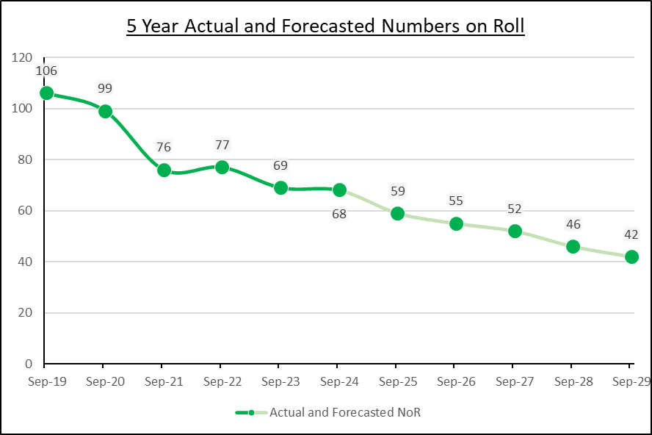

**September 2025**

Flintshire County Council School Admissions has announced that as of the current publication date, ?? reception class places have been assigned for September 2025, over/under the anticipated figure of ??. ?? nursery places have been allocated, over/under of the projected ??. Collectively, these figures indicate a stable/concerning availability of places at St Anthony’s.

<awaiting information>

### St David’s Catholic Voluntary Aided Primary School, Mold



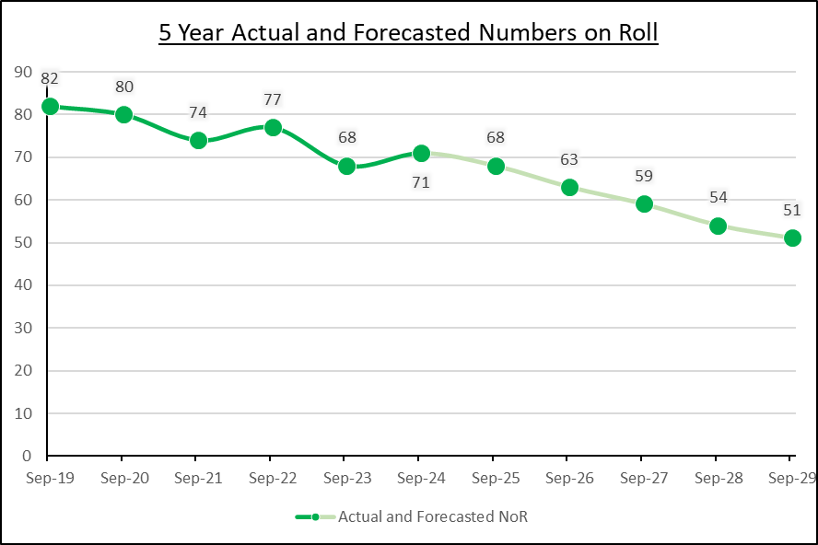

**September 2025**

Flintshire County Council School Admissions has announced that as of the current publication date, ?? reception class places have been assigned for September 2025, over/under the anticipated figure of ??. ?? nursery places have been allocated, over/under of the projected ??. Collectively, these figures indicate a stable/concerning availability of places at St David’s.

<awaiting information>

### St Mary’s Catholic Voluntary Aided Primary School, Flint



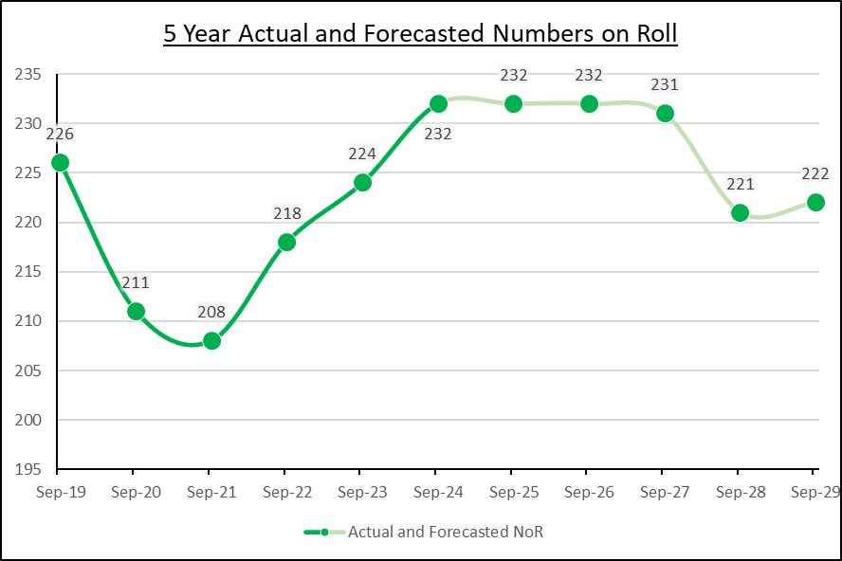

**September 2025**

Flintshire County Council School Admissions has announced that as of the current publication date, ?? reception class places have been assigned for September 2025, over/under the anticipated figure of ??. ?? nursery places have been allocated, over/under of the projected ??. Collectively, these figures indicate a stable/concerning availability of places at St Mary’s.

<awaiting information>

### St Richard Gwyn Catholic Voluntary Aided Secondary School, Flint



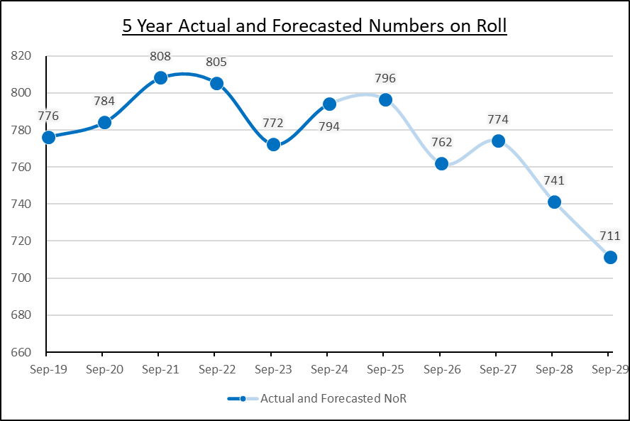

**September 2025**

Flintshire County Council School Admissions has announced that as of the current publication date, ?? Year 7 class places have been assigned for September 2025, over/under the anticipated figure of ??. ?? sixth places have been allocated, over/under of the projected ??. Collectively, these figures indicate a stable/concerning availability of places at St Richard Gwyn.

<awaiting information>

## Quality of Education Provision

Quality and standards in schools in Flintshire are monitored by Estyn and the Council. Estyn is the office of Her Majesty’s Chief Inspector of Education and Training in Wales. It is a Crown body, established under the Education Act 1992. Estyn is independent of the Senedd but receives its funding from the Welsh Government under Section 104 of the Government of Wales Act 1998. Estyn inspects quality and standards in education and training providers in Wales.

Comments on the curriculum provision of the four schools, taken from their most recent Estyn inspection reports, are shown below. Also within each school section is a link to the report and a summary of any recommendations.

### St Anthony’s Catholic Voluntary Aided Primary School, Saltney

*“There is an effective working relationship between adults and pupils, which supports a purposeful learning environment. Teachers prepare effective lessons and activities flow well. They explain new ideas carefully and extend pupils’ learning through practical experiences well. They ask probing questions to broaden pupils’ understanding and encourage them to use their thinking skills throughout the lesson. Support staff make a positive contribution to the quality of pupils’ learning.”*

The full report can be found here:

<https://estyn.gov.wales/system/files/2021-08/Inspection%20report%20St%20Anthony%27s%20R.C.%20Primary%20School%202019.pdf>

Recommendations

* Improve standards in Welsh as a second language across the school.
* Improve attendance overall.
* Provide more opportunities for pupils in key stage 2 to take responsibility for their own learning in order to develop as independent learners.
* Provide more opportunities for pupils to develop their numeracy and information and communication technology (ICT) skills across different areas of learning.

### St David’s Catholic Voluntary Aided Primary School, Mold

*“Teachers and support staff work well together to plan and deliver a wide range of learning experiences that engage most pupils’ interest effectively. They know the pupils well and give them effective support while they work and interact with other pupils. This has a positive effect on pupils’ standards and wellbeing. Teachers have up-to-date subject knowledge and use a suitable variety of effective teaching*

*methods that motivate pupils to learn. Support staff work alongside teachers skilfully and contribute effectively to pupils’ learning”*

The full report can be found here:

<https://estyn.gov.wales/system/files/2022-01/St%2520David%2527s%2520Catholic%2520Primary%2520School_1.pdf>

Recommendations

* Challenge all pupils in key stage 2 to improve and to guide their own learning in order to achieve to the best of their ability
* Sharpen monitoring procedures so that they focus more clearly on pupil outcomes
* Ensure that all processes relating to the provision for pupils with special educational needs are robust and give a clear overview of pupils’ progress
* Improve the quality of pupils’ extended writing in key stage 2

### St Mary’s Catholic Voluntary Aided Primary School, Flint

*“Overall, the quality of teaching at the school is good. All staff know their pupils well and many respond sensitively to the needs and interests of individuals. Most staff manage pupils’ behaviour well. Many teaching assistants know when to intervene and provide effective support to individuals and groups of pupils, particularly those pupils who have English as an additional language.”*

The full report can be found here:

<https://estyn.gov.wales/system/files/2020-08/St%2520Mary%2527s%2520R.C.%2520Primary%2520School_3.pdf>

Recommendations

* Plan for pupils to have more opportunities to develop their ICT skills
* Improve links between self-evaluation and school development plans
* Comply with Welsh Government guidance when planning spending of specific grants
* Plan opportunities to develop pupils’ independent learning skills
* Improve processes to monitor attendance
* Address the safeguarding issue identified during the inspection

### St Richard Gwyn Catholic Voluntary Aided Secondary School, Flint

*“Most teachers establish positive and purposeful relationships with pupils to support their learning. They know their pupils well and maintain caring learning environments. Many teachers have well-established routines for the start of lessons. They explain the learning intentions clearly and use frequent questioning to check that pupils understand. These teachers are good language models and ensure that pupils know what they must do. They have good subject knowledge and use praise judiciously to encourage learning. A minority of teachers are particularly enthusiastic and share their passion for their subject. They provide clear explanations of concepts, model expectations for learning well and provide useful verbal feedback on how to improve.”*

The full report can be found here:

<https://estyn.gov.wales/app/uploads/2024/07/Inspection-report-St-Richard-Gwyn-Roman-Catholic-High-School-2024-1.pdf>

Recommendations

* Improve the quality of teaching to improve engagement and pupils’ progress in learning to address the shortcomings identified in the report
* Ensure that self-evaluation and improvement processes focus more precisely on improving teaching and its impact on pupils’ progress
* Develop a strategic approach to planning, evaluating and improving the progressive development of pupils’ skills for all pupils
* Ensure that all pupils have full access to provision to develop their Welsh language skills

### Education Provision Areas

**Standards**

The new state-of-the-art school facilities will enable the teaching staff to deliver enhanced educational provision, subsequently improving learning opportunities for the students.

**Wellbeing and attitudes to learning**

The construction of a state-of-the-art school facility will enhance the wellbeing of both staff and students by providing access to resources and amenities that will improve educational provision and foster more positive attitudes towards learning.

The new school's design will incorporate input from the school's stakeholders to ensure it aligns with the school's curriculum vision and overall ethos, thereby maximising its positive impact on student wellbeing and learning engagement.

**Teaching and learning experiences**

The new school will provide pupils and staff with enhanced access to resources and facilities, thereby improving the overall teaching and learning experience. Additionally, the school will offer greater opportunities for professional development and a broader range of curricular activities.

**Care, support and guidance**

The inclusive and nurturing learning environments of the current schools will be transitioned to the new school, accompanied by their respective teaching staff. The new school's enhanced facilities will provide greater resources and improved amenities to better support the learners.

**Leadership & Management**

The new school's leadership will be strengthened by the exchange of best practices between current school leaders and their accumulated experience. Furthermore, structures will be developed to offer a broader range of opportunities for both staff and students. As a result, students will benefit from enhanced learning opportunities and a wider scope of curricular activities.

# THE PROPOSAL

## What is being proposed?

Following conversations with the Diocese, the Council propose to reorganise the Catholic education provision in Flintshire.

The proposal will involve two distinct elements:

* The closures of St Anthony’s Catholic VA Primary School in Saltney, St David’s Catholic VA Primary School in Mold, St Mary’s Catholic VA Primary School in Flint and St Richard Gwyn Catholic VA High School in Flint.
* The opening of a new English medium 3-18 Catholic Voluntary Aided School in Flint.

## What will the proposal provide

The proposal will be facilitated by a capital build project, which will be delivered through the Council's Capital Development Programme.

This project will:

* Construct a new 3-18 English medium Catholic voluntary aided school in Flint, on the adjoining sites that currently have St Mary’s and St Richard Gwyn on them.
* The overall capacity of the school will be for 1185 pupils.
* Capacity will be divided between 315 full-time primary pupil places and 750 secondary full-time pupil places. Sixth-form accommodation will be provided for 120 part-time pupils.
* Nursery accommodation will be provided for 45 part-time pupils.

## When will the proposal be effective?

It is anticipated that a final decision whether or not to proceed with the proposal, should it get to this point, would be taken in early 2026.

If the proposal is to be implemented, immediately after the final decision will see a period of design development begin. During this process St Anthony’s is proposed to close by September 2026. Construction on the new school would commence in early 2027 and be completed by August 2029.

This will allow the closures of St David’s, St Mary’s and St Richard Gwyn to be formally concluded and the new school to be opened September 2029.

## Cost of the Proposal

The project will require an estimated capital investment of £55,000,000. Financing this has been made possible by the Council’s capital borrowing and from Welsh Government’s Sustainable Communities for Learning funding.

The Welsh Government’s Sustainable Communities for Learning funding programme aims to:

* improve the quality of school buildings
* ensure places are available to serve local pupil demand
* reduce surplus capacity
* reduce running costs
* promote sustainability

Under Welsh Government Sustainable Community for Learning funding conditions, Welsh Government will contribute 85% of the total project costs, with the remaining 15% funded by Council capital borrowing.

One of the drivers for the proposal is equality of funding for pupils and through the closing of four schools and opening of a new 3-18 school the cost per pupil for the Catholic education provision will be rationalised.

As part of the Council’s funding formula, schools are funded on the number of pupils and on other non-teaching costs. The new school will be funded using this formula, with a single budget that will be smaller than the budget of operating as four separate schools.

In Flintshire, the average primary school budget cost per pupil in 2025 / 2026 is £5,667. Budgets and cost per pupils for the individual schools during the same period are as follows:

* The revenue allocation for St Anthony’s is £433,628 with a budget share per pupil figure of £6,107.
* The revenue allocation for St David’s is £450,633 with a budget share per pupil figure of £6,008.
* The revenue allocation for St Mary’s is £1,141,631 with a budget share per pupil figure of £4,468.

In Flintshire, the average secondary school budget cost per pupil in 2025 / 2026 is £6,041.

* The revenue allocation for St Richard Gwyn during the same period is £4,495,115 with a budget share per pupil figure of £5,661

## Options Considered

In total, 6 options were considered before the preferred option was identified. The advantages and disadvantages of each option formed the basis of each outcome and the eventful identification of the preferred option.

|  |  |
| --- | --- |
| **Option 1 - Maintain the Status Quo** | |
| Allow all Catholic schools to continue without any intervention. | |
| **Advantages** | **Disadvantages** |
| * Requires no investment * All schools retained in their respective communities * No disruption to pupils | * Does not address maintenance issues * Does not address high numbers of surplus places * Does not provide a sustainable long-term solution * No appetite to do nothing |
| **Outcome – Option Discounted** | |

|  |  |
| --- | --- |
| **Option 2 – Do Minimum** | |
| Address all backlog maintenance issues at all schools. | |
| **Advantages** | **Disadvantages** |
| * Requires relatively minor investment * Backlog maintenance issues addressed * All schools retained in their respective communities * No disruption to pupils | * Does not address high numbers of surplus places * Does not provide a sustainable long-term solution |
| **Outcome – Option Discounted** | |

|  |  |
| --- | --- |
| **Option 3 - New 3-18 Catholic School in Flint (2 schools)** | |
| Amalgamate St Mary’s and St Richard Gwyn  Inject significant investment into the Flint site (either a completely new build or extensive remodelling/ refurbishment)  Retain St Anthony’s, St David’s, St Winefride’s and Venerable Edward Morgan | |
| **Advantages** | **Disadvantages** |
| * Through school experience for Flint pupils, easing transition * Shared leadership and governance * Through school development and curriculum with shared expertise * Four primary schools retained in their respective communities * Minimal disruption to pupils | * Considerable financial investment required * Does not address maintenance issues at four other primary schools * Does not significantly address high numbers of surplus places * Does not provide a sustainable long-term solution |
| **Outcome – Option Discounted** | |

|  |  |
| --- | --- |
| **Option 4 - New 3-18 Catholic School in Flint (4 schools)** | |
| Close St Anthony’s, St David’s, St Mary’s and St Richard Gwyn  Construction of a purpose built new 3-18 school in Flint  Retain St Winefride’s and Venerable Edward Morgan | |
| **Advantages** | **Disadvantages** |
| * New, modern facilities designed for a contemporary curriculum * Net zero carbon building(s) * Significantly reduces maintenance issues and cost across the Catholic sector * Through school experience for Flint pupils, easing transition * Through school development and curriculum with shared expertise * Shared leadership and governance * Potential for greater staff development opportunities * Significant reduction in surplus places * Sustainable long-term solution * Two primary schools retained in their respective communities | * Considerable financial investment required * Does not address maintenance issues at two other primary schools * Removes two schools from their local communities * Increased journey times for pupils at, and those who would have attended, St Anthony’s and St David’s to their next nearest Catholic primary school * Potential loss of pupils who are currently attending, or would potentially attend, St Anthony’s and St David’s to non-Catholic alternatives * Potential loss of employment opportunities in Saltney and Mold areas * Loss of historical school settings |
| **Outcome – Option Preferred** | |

|  |  |
| --- | --- |
| **Option 5 - New 3-18 Catholic School in Flint (6 schools)** | |
| Close St Anthony’s, St David’s, St Mary’s, St Winefride’s, Venerable Edward Morgan and St Richard Gwyn  Construction of a purpose built new 3-18 school in Flint | |
| **Advantages** | **Disadvantages** |
| * New, modern facilities designed for a contemporary curriculum * Net zero carbon building(s) * One centralised Catholic provision * Removes maintenance issues and cost across the Catholic sector * Through school experience for Flint pupils, easing transition * Through school development and curriculum with shared expertise * Shared leadership and governance * Potential for greater staff development opportunities * Significant reduction in surplus places * Sustainable long-term solution | * Considerable financial investment required * Removes four schools from their local communities * Increased journey times for pupils at, and those who would have attended, St Anthony’s, St David’s, St Winefride’s and Venerable Edward Morgan to their next nearest Catholic primary school * Potential loss of pupils who are currently attending, or would potentially attend, St Anthony’s, St David’s, St Winefride’s and Venerable Edward Morgan to non-Catholic alternatives * Potential loss of employment opportunities in Saltney, Mold, Holywell and Shotton areas * Loss of historical school settings |
| **Outcome – Option Discounted** | |

|  |  |
| --- | --- |
| **Option 6 - New 3-18 Catholic School in Flint (4 schools) and Federation (2 schools)** | |
| Close St Anthony’s, St David’s, St Mary’s and St Richard Gwyn  Construction of a purpose built new 3-18 school in Flint  Federate St Winefride’s and Venerable Edward Morgan | |
| **Advantages** | **Disadvantages** |
| * New, modern facilities designed for a contemporary curriculum * Net zero carbon building(s) * Significantly reduces maintenance issues and cost across the Catholic sector * Through school experience for Flint pupils, easing transition * Through school development and curriculum with shared expertise * Shared leadership and governance * Potential for greater staff development opportunities * Significant reduction in surplus places * Sustainable long-term solution * Two primary schools retained in their respective communities * Two primary schools retain their individual identities * Federation provides shared vision, resources, polices, governance across two schools | * Considerable financial investment required * Does not address maintenance issues at two other primary schools * Removes two schools from their local communities * Increased journey times for pupils at, and those who would have attended, St Anthony’s and St David’s to their next nearest Catholic primary school * Potential loss of pupils who are currently attending, or would potentially attend, St Anthony’s and St David’s to non-Catholic alternatives * Potential loss of employment opportunities in Saltney and Mold areas * Approximately 10 miles between federated sites which may reduce any potential positive impacts * Loss of historical school settings |
| **Outcome – Option Discounted** | |

## What will the preferred proposal achieve?

If implemented, the proposal will significantly reduce the large number of surplus primary school places in the Catholic education provision, reduce running costs whilst providing a new modern learning environment fit for purpose and to enhance learning opportunities for children.

# LIKELY IMPACTS OF THE PROPOSAL

Outlined below are key impacts that are anticipated should the Proposal be implemented.

## Impact on the Local Environment

During the design development phase traffic impacts of constructing the new school will be assessed and any anticipated negative consequences will be removed or reduced to ensure minimal impact.

Safe routes to school and active travel arrangements will be considered in partnership with colleagues in Planning and Streetscene Teams. A coherent travel strategy and school travel plan will be put in place to promote ecologically friendly travel choices.

The removal of two buildings and a school built to a Net Zero Carbon in Operation (NZCio) standard would remove emissions from the Council’s carbon footprint by incorporating renewable energy systems and natural ventilation and shading.

## Impact on Admissions

Admission arrangements for the new school will be determined and administered by the new governing body. This approach is used by the governing bodies of the four current schools and will not change following implementation.

Every pupil enrolled at St Anthony’s and St David’s will be assured a position in an alternative Catholic school, irrespective of their residence.

## Impact on Home to School Transport

The Council is required to determine whether the provision of transport for pupils of statutory school age is necessary to facilitate the attendance at a designated school of the pupil concerned. If such transport is deemed necessary, then the transport must be provided free of charge

The Council provides free transport for children of compulsory school age (i.e. 5-16yrs) as follows:

* where a child receiving primary education lives over two miles from the nearest appropriate school
* where a child receiving secondary education lives over three miles from the nearest appropriate school.

In addition to its statutory obligations, the Council also provides free transport for pupils of statutory age to the nearest voluntary aided school where the admission to the school is on denominational grounds, subject to the distance criteria.

The full Transport Policy can be found via the following link:

<https://www.flintshire.gov.uk/en/Resident/Schools/School-Transport-Application.aspx>

A Transport Impact Assessment has concluded that closing St Anthony’s and St David’s would:

* Significantly increase average walking distances for pupils at these school to their next nearest Catholic primary school
* Significantly increase journey times for pupils at these school to get to their next nearest Catholic primary school
* Significantly increase costs to the Council to provide transport for all pupils at these school to get to their next nearest Catholic primary school (actual costs cannot be determined

The full Transport Impact Assessment can be found here:

<insert link>

## Impact on Transfer to Secondary Schools

There will be no change to the current transfer arrangements for pupils in respect of secondary education. The transition arrangements for primary school pupils in Flint should be improved due to being part of the 3-18 school.

## Impact on Additional Learning Needs Pupils

Those pupils with ALN / SEN (which term is used are are they different?) will lose access to provision offered in the Saltney and Mold areas. However, the ALN provision in the new school will be considered during the design development process and will likely be enhanced beyond the current offering in Flint with new state-of-the-art facilities and additional resources available.

## Impact on Governance Arrangements

During design development representatives from the governing bodies of the Flint schools will form a ‘shadow’ governing body / working group to contribute to the facilities at the new school. Approaching the completion of the new school the ‘shadow’ governing body / a new governing body will be established.

## Impact on Staffing

Staffing requirements at a school are derived from the number of pupils at a school. Therefore, if all the pupils are retained within Flintshire’s Catholic education provision, overall staffing numbers may not change that much.

However, what the proposal will impact is the location where jobs are available. Opportunities to work in Saltney and Mold will be removed but there could be additional opportunities created in Flint, Shotton and Holywell, depending upon where pupils migrate to.

Staff will be supported through any changes by the Council’s Employment Services (is this the right term?) teams.

The Proposal may also present more and higher quality professional development opportunities for staff.

## Impact on Other schools

The Code states that impacts on schools likely to be affected by a proposal should also be considered. There is/are no criteria set out in the Code to determine a school that will “likely be affected” by a proposal. Therefore, the Council usually compares schools of same type and language relatively close to the main school(s).

As there are only two other Catholic schools in Flintshire, consideration has been given to whether either would ‘likely be affected’. St Winefride’s Catholic Voluntary Aided Primary School in Holywell is not likely to be significantly impact by the Proposal due to the home location of pupils currently attending St Anthony’s and St David’s.

However, for the majority current pupils attending St Anthony’s and St David’s, should the schools close, their next nearest Catholic primary school would be Venerable Edward Morgan Catholic Voluntary Aided Primary School in Shotton. Therefore, it is reasonable to determine that Venerable Edward Morgan is likely to be affected by the Proposal.

If all pupils currently attending St Anthony’s and St David’s transferred to Venerable Edward Morgan then numbers on roll at the school would increase from 167 (September 2024) to 284. The school has capacity to accommodate 281 full-time pupils and would see surplus places reduce from 114 to being 3 places oversubscribed.

Full information for Venerable Edward Morgan is shown below.

### Venerable Edward Morgan Catholic Primary School, Shotton

### Current Position

|  |  |  |  |
| --- | --- | --- | --- |
| **Location of the School** | | Caernarfon Close, Shotton CH5 1AR | |
| **Age Range** | | 3-11 | |
| **School Category** | | Voluntary Aided | |
| **Language Medium Category** | | English medium | |
| **Faith denomination** | | Catholic | |
|  | | Reception – Year 6 | Nursery |
| **Number of pupils on the school register** | **September 2020** | 201 | 18 |
| **September 2021** | 196 | 12 |
| **September 2022** | 184 | 17 |
| **September 2023** | 165 | 23 |
| **September 2024** | 167 | 19 |
| **Capacity** | **September 2024** | 281 | 16 |
| **Surplus Places** | **September 2024** | 114 | -3 |
| **Pupil Forecasts** | **September 2025** | 157 | 21 |
| **September 2026** | 151 | 22 |
| **September 2027** | 146 | 21 |
| **September 2028** | 141 | 22 |
| **September 2029** | 149 | 22 |
| **Building Condition Category** | Condition C - Poor  Exhibiting major defects and/or not operating as intended. | | |
| **Building Suitability** | B - Satisfactory  Performing as intended but does not support the Curriculum in some areas | | |
| **Cost to Resolve Condition Issues** | £305,600  This is exclusive of any applicable fees, preliminaries, and VAT. | | |

### School Location

Shotton is a town consisting of two electoral wards of Flintshire, situated north east of Mold. The resident population two wards, as measured in the 2021 census, was 6,499.

### Demographical Information

Demographically analysis (as at September 2024) has shown that 94.64% of pupils attending Venerable Edward Morgan are attending their nearest English-medium voluntary aided Catholic primary school.

Map of locations of pupils attending Venerable Edward Morgan.

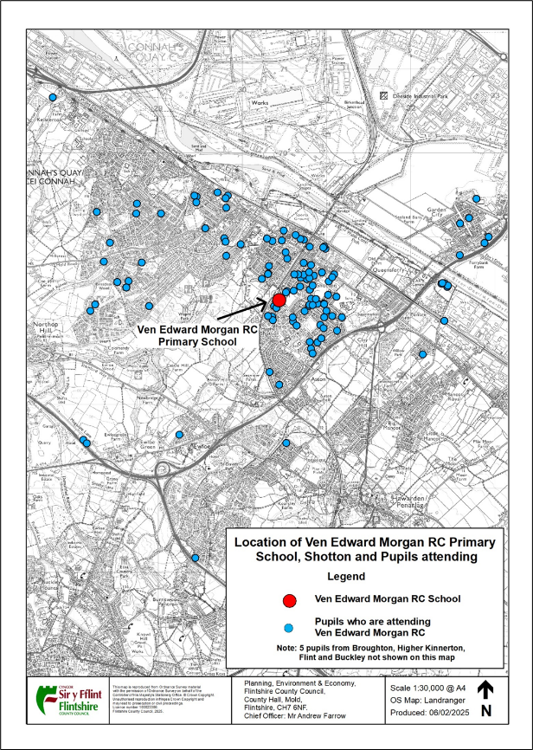

### Pupil Forecasts



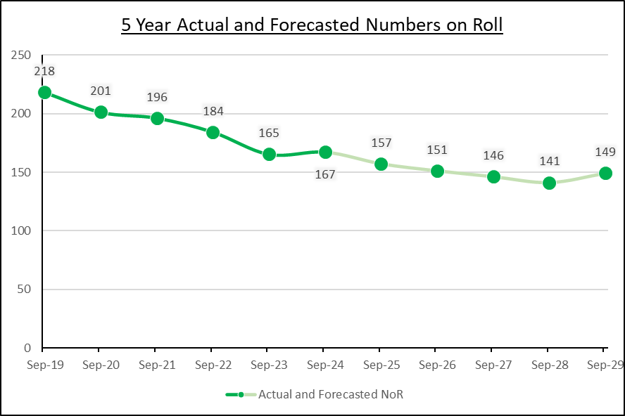

### Quality of Education Provision

*“Most teaching is effective and supports pupils’ learning well. Nearly all teachers plan interesting lessons that build positively on pupils’ prior learning and make good use of a wide range of resources. They use effective teaching approaches to engage pupils in their learning successfully. Most teachers create a positive atmosphere that ensures that nearly all pupils feel valued and are keen to learn. Additional adults contribute successfully to the learning and wellbeing of the individuals and groups of pupils they support. Almost all teachers establish effective classroom routines and use individual, pair and group work to good advantage. In most lessons, teachers use skilful questioning to promote pupils’ understanding. They intervene at appropriate times and provide effective support to all groups of pupils. However, in the very few lessons where teaching is less effective, the pace of learning is slow and teachers do not adapt learning well enough to challenge all pupils at an appropriate level, particularly those who are more able.”*

The full report can be found here:

<https://estyn.gov.wales/system/files/2020-08/Ven.%2520Edward%2520Morgan%2520R.C.%2520Primary%2520School.pdf>

Recommendations

* Continue to improve attendance
* Ensure that teaching challenges all pupils at an appropriate level, particularly those who are more able
* Improve the consistency of teachers’ feedback so that pupils know how to improve their work
* Strengthen communication with parents to promote aspects of the school’s work more effectively

## Risks of the Proposal

Key risks of the proposal include:

| **RISK** | **POTENTIAL MITIGATION** |
| --- | --- |
| The consultation may uncover an alternative approach which could offer a long-term solution to safeguard the Catholic education sector in Flintshire | Any alternative approach will be assessed to determine its viability. Once established a decision will be taken to either continue with this proposal or pursue the alternative. |
| Overall affordability of the project | The affordability of the project is under constant review. The Council constantly monitors costs of project to ensure they remain within budget. Any significant increases in costs will result in a pause of the project in order to review causes and identify potential solutions. |
| 85% of funding is to be obtained from Welsh Government but there is no guarantee that any funding application will be successful | Without this funding the proposal cannot be implemented. |
| The remaining 15% funding requirement is to be provided by the Council which has significant financial pressures, as do all local authorities | The proposed scope of the project and outline design has been commercially assessed and is considered affordable within the Flintshire County Council capital programme envelope. |
| Increased pupil transport costs for the Council | Possible revision of school transport policy may be required |
| The estimated completion date may not be met | The anticipated timeline is a guide and is subject to various stages that mean the proposal may take longer to deliver. However, with extensive previous experience delivering similar projects the timeline is viewed as realistic. |
| Loss of pupils to non-Catholic provision due to uncertainty of the future offering | The proposed Catholic provision will have sufficient space to accommodate all current pupil numbers on roll. |
| Possible resistance to or disengagement with the change process amongst stakeholders | Presentation of clear information and data to allow stakeholders to fully participate in the consultation process. |

## Integrated Impact Assessment

An integrated impact assessment has been conducted for this proposal and is available on the Council website.

## Impact on Welsh language provision

This proposal will not support the Council’s objectives under its Welsh in Education Strategic Plan (WESP). The Council has made a significant investment in Welsh-medium education since 2020, with over £20m being used on a new primary school, extensions to another and refurbishment of another. In addition, funding has delivered a number of Welsh-medium childcare settings to provide access to the Welsh language at an early age.

It is anticipated that the proposal would not negatively impact the Welsh language provision within the County as the number of full-time Welsh-medium pupil places will be unaffected. Whilst the Council supports the drive to increase the number of Welsh speakers, it also has a responsibility to provide high quality opportunities for non-Welsh speaking pupils too.

## Building Impacts

The futures of the sites at Saltney and Mold are yet to be determined and will be managed in accordance with the agreed Council Policy on Surplus Land and Buildings.

## Interim Arrangements

Although the new school would be constructed on the same site as St Mary’s and St Richard Gwyn, the site is big enough to allow construction to happen whilst the two schools remain in operation. Therefore, implementation of the proposal will not require any interim arrangements.

# RESPONSES

## Consultation Response Pro-forma

This response form relates to the proposal that involves:

* The closures of St Anthony’s Catholic VA Primary School in Saltney, St David’s Catholic VA Primary School in Mold, St Mary’s Catholic VA Primary School in Flint and St Richard Gwyn Catholic VA High School in Flint.
* The opening of a new English medium 3-18 Catholic Voluntary Aided School in Flint.

Your views matter.

Please tell us what you think about the proposal by completing this questionnaire via the following link:

<insert link>

Alternatively, you can print this form, complete your response and either email it or return it by post to the addresses below:

21stCenturySchools@flintshire.gov.uk

School Modernisation Team

Flintshire County Council

Ty Dewi Sant

St David’s Park

Ewloe

Flintshire CH5 3XT

The closing date for the submission of responses to this consultation is **midnight ?? June 2025**.

Please note that negative responses made to this consultation will not be counted as objections to the proposal, they will be recorded as adverse comments. Objections can only be registered following the publication of a statutory notice.

1. Please indicate how you are associated with the schools involved in the Proposal:

Parent, carer or guardian

Prospective parent, carer or guardian

Governor

Member of staff

Member of the community

Organisation e.g. Community Council

No Association

Other (Please specify): _____________________

1. If you are associated with any school(s), please specify which school(s) you are associated with:

St Anthony’s Catholic Voluntary Aided Primary School, Saltney

St David’s Catholic Voluntary Aided Primary School, Mold

St Mary’s Catholic Voluntary Aided Primary School, Flint

St Richard Gwyn Catholic Voluntary Aided Secondary School, Flint

No Association

Other (Please specify) _______________________

1. Do you support the proposal to:

Close St Anthony’s Catholic VA Primary School in Saltney, St David’s Catholic VA Primary School in Mold, St Mary’s Catholic VA Primary School in Flint, St Richard Gwyn Catholic VA High School in Flint and then open a new English medium 3-18 Catholic Voluntary Aided School in Flint.

Yes ☐ No ☐

Please use the box below to provide comments or explain which element of the

proposal you do or do not support

|  |
| --- |
|  |

1. Do you believe that the proposal will have a positive or negative effect on opportunities to use the Welsh language?

Positive ☐ Negative ☐ No effect ☐

1. If you think it will have a negative effect, what steps could we take to lessen or remove this and improve positive effects?

|  |
| --- |
|  |

1. Do you believe that the proposal will treat the Welsh and English languages equally?

Yes ☐ No ☐

|  |
| --- |
|  |

If you wish to be notified of publication of the consultation report please provide an email address and postal address in the box below

|  |
| --- |
|  |

|  |
| --- |
| **E2. Equality Monitoring Information**  In order to monitor the inclusiveness of our engagement, we would appreciate your co-operation in providing the information requested below. The information is confidential and anonymous, and will be used solely for statistical monitoring purposes. It will be securely destroyed after we have captured the information. |
| |  | | --- | | **Providing this information is entirely voluntary** |  |  |  | | --- | --- | | **Please provide your date of birth (DD/MM/YYYY):** |  | |

|  |  |
| --- | --- |
| **What is your Sex:** | |
| Male |  |
| Female |  |
| Prefer not to say |  |
| Other: |  |

|  |  |  |  |
| --- | --- | --- | --- |
| **How would you describe your nationality:** | | | |
| British |  | Scottish |  |
| English |  | Welsh |  |
| Irish |  | Prefer not to say |  |
| Northern Irish |  | Other: |  |

|  |  |  |  |
| --- | --- | --- | --- |
| **How would you describe your ethnicity:** | | | |
| White British |  | White English |  |
| White Northern Irish |  | White Scottish |  |
| White Welsh |  | White Irish |  |
| White - Gypsy or Irish Traveller |  | White - Other |  |
| Mixed British - White / Black Caribbean |  | Mixed British - White / Black African |  |
| Mixed British - White / Asian |  | Mixed British – Any other mixed background |  |
| Black British - Caribbean |  | Black British - African |  |
| Black British – Any other black background |  | Asian – Indian |  |
| Asian - Bangladeshi |  | Asian - Pakistani |  |
| Asian - Chinese |  | Asian – Asian Other |  |
| Other British – Arab |  | Prefer not to say |  |
| Other: |  |  |  |

|  |  |  |  |
| --- | --- | --- | --- |
| **Sexual Orientation: Which of the following options best describes how you think of yourself? (Note this question is only be asked of people age over 16.)** | | | |
| Heterosexual / Straight |  | Bisexual |  |
| Gay Man |  | Prefer not to say |  |
| Gay Woman / Lesbian |  | Other: |  |

|  |  |  |  |
| --- | --- | --- | --- |
| **What is you religion?** | | | |
| Christian (all denominations) |  | Jewish |  |
| Buddhist |  | Atheist |  |
| Hindu |  | No religion |  |
| Muslim |  | Prefer not to say |  |
| Sikh |  | Other: |  |

|  |  |  |  |
| --- | --- | --- | --- |
| **Are you married or in a same-sex civil partnership?** | | | |
| Yes |  | No |  |
| Prefer not to say |  |  |  |

|  |  |  |  |
| --- | --- | --- | --- |
| **Disability: Using the definition below do you consider yourself to be disabled?**  **Section 6(1) of the Equality Act 2010 states that a person has a disability if:**  **(a) That person has a physical or mental impairment, and**  **(b) The impairment has a substantial and long-term adverse effect on that person’s ability to carry out normal day-to-day activities.** | | | |
| Yes |  | No |  |
| Prefer not to say |  |  |  |

|  |  |  |  |
| --- | --- | --- | --- |
| **Caring Responsibilities: Do you look after or give help or support to family members, friends, neighbours or others because of long term physical or mental ill-health/disability or problems related to old age?** | | | |
| Yes |  | No |  |
| Prefer not to say |  |  |  |

|  |  |  |  |
| --- | --- | --- | --- |
| **What is your preferred language?** | | | |
| English |  | Welsh |  |
| Prefer not to say |  | Other (including British Sign Language) |  |